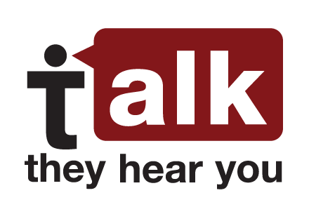
Live Read Radio scripts – English and Spanish
Underage Drinking Prevention National Media Campaign
“Talk. They Hear You.”
:15 Live Read Script ENGLISH

ANNCR: Too many pre-teens are already drinking alcohol. For tips on how to talk to your kids, visit Talk. They Hear You. at www.underagedrinking.S-A-M-H-S-A.gov. That’s underagedrinking.S-A-M-H-S-A.gov.
“Talk. They Hear You.”
:30 Live Read Script ENGLISH

ANNCR: An alarming number of pre-teens are already drinking alcohol. Which makes it urgent to find every opportunity to talk to your kids about the dangers of underage drinking. They really do hear you. For tips on what to say, visit underagedrinking.SAMHSA.gov. That’s www.underagedrinking.S-A-M-H-S-A.gov. Talk. They Hear You. A public service message from the Substance Abuse and Mental Health Services Administration.
“Talk. They Hear You.”
:15 Live Read Script SPANISH

ANNCR: Demasiados preadolescentes ya beben alcohol. Para obtener consejos sobre cómo hablarles a sus hijos, visite el sitio “Hable”. “Ellos lo escuchan”, en “underagedrinking punto S-A-M-H-S-A punto gov”.

“Talk. They Hear You.” Radio
:30 Live Read Script SPANISH

ANNCR: Una cantidad alarmante de preadolescentes ya beben alcohol. Por eso es urgente que aproveche toda oportunidad para hablarles a sus hijos sobre los peligros del consumo de alcohol entre menores. Ellos realmente lo escuchan. Para obtener consejos sobre qué decir, visite underagedrinking punto S-A-M-H-S-A punto gov. Hable. Ellos lo escuchan. Un mensaje de servicio público de la Administración de Servicios de Abuso de Sustancias y Salud Mental.

