

# Together we can recover.

Program logo   
and name

Together we   
can recover.

Program logo   
and name

Program name   
and address

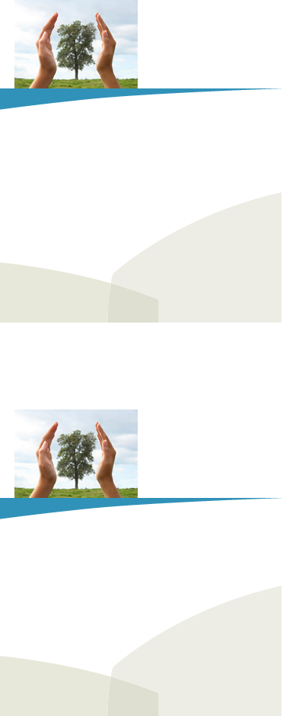

PRST-STD

U.S. POSTAGE

PAID

CITY, ST

PERMIT NO. XXX

YOU ARE NOT ALONE WE ARE HERE TO HELP.

We provide information, educational resources, and emotional support.

Call us at [Insert Program Number Here].

We are free and confidential.

Program logo and name

Are you interested in:

* Talking to someone?
* Learning how to manage your stress?
* Understanding common reactions to disasters?

Program phone number   
and website

Program name   
and address

PRST-STD

U.S. POSTAGE

PAID

CITY, ST

PERMIT NO. XXX

YOU ARE NOT ALONE WE ARE HERE TO HELP.

We provide information, educational resources, and emotional support.

Call us at [Insert Program Number Here].

We are free and confidential.

Program logo and name

Are you interested in:

* Talking to someone?
* Learning how to manage your stress?
* Understanding common reactions to disasters?

Program phone number   
and website